Analysis

The margins of safety (MS) for the mounting bolts of the antenna assembly were calculated. To do this a load of 404lbf was assumed. This was calculated during an emergency landing. The maximum loading in the emergency landing scenario occurs in the front load case; a 9g load factor. This can be seen in equation ____.
Using the screw yield stress in both shear and tension it was possible to calculate the MS. In this calculation it is assumed that the 6, stainless steel mounting bolts equally share the loading.
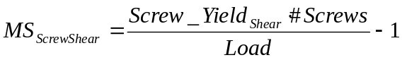

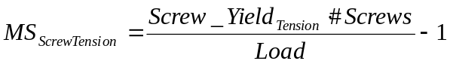

The MS of both loading cases (Shear and tension) result in a margin of safety greater than six. This implies that a single bolt can support the maximum load.

Next the stresses on the antenna cover were calculated. This is the main structural member of our antenna assembly. The loads acting on the cover were calculated in order to correctly analyze it. The two main loads acting on the cover are the weight of the assembly (40lbf) and the drag force or pressure from the air during operation. The drag force is calculated using a drag coefficient (C_{d}) that was assumed based on the shape and material used to build the cover. The drag also depends on the density of the air (ρ, assumed to be dry air at 20ºC), the surface area (A), and the velocity (v, operational velocity = 44.44m/s) as seen in equation ______.
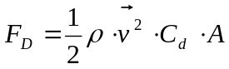
In order to correctly apply the drag force to the antenna cover for analysis the force was converted to a drag pressure (P_{d}) that was applied to the surfaces in contact with the air. Note that the trailing edges of the cover will not be in contact with the air due to boundary layer separation. The drag pressure was calculated as seen in equation _______.
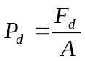
The Pro/E model of the 6061-T6 aluminum antenna cover was imported into ANSYS Workbench in order to substantiate its design. The maximum displacement and maximum stress of the antenna cover was calculated using the drag pressure and weight as its loading scenario (Refer to appendix to see loading orientation and stress and displacement results).

A MS for the Antenna Cover was calculated using the maximum stress from the ANSYS analysis. The MS for the antenna cover was calculated using the yield stress of the aluminum and a safety factor of 1.5 (Standard for aircraft analysis).
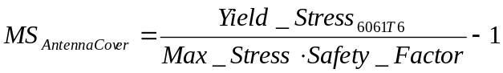

Results

Total System Power Consumption = 324.2W
Total System Weight = 20.4kg = 44.88lb
Max Von Mises Stress on Antenna Cover = 0.692 MPa
- Stress result of weight loading and drag for loading
Max Displacement of Antenna Cover during Loading = 1.59mm
Margin of Safety for Antenna Cover Stress = 265
Margin of Safety for Mounting Bolts in Shear = 10
Margin of Safety for Mounting Bolts in Tension = 8.4

Appendix

Antenna Assembly Weights

Component | Weight (kg) | Qty | Total Weight (kg)
Antenna Cover | 4.845 | 1 | 4.845
Mounting Hardware | 1.4 | 1 | 1.4
Backplate Board | 0.59 | 1 | 0.59
Cables and Other Various Electrical Components | 4.845 | 1 | 4.845
Antenna | 0.227273 | 24 | 5.454545455
High Power Amplifier | 0.136364 | 24 | 3.272727273
 |  | TOTAL | 20.40727273

Antenna Assembly Power Consumption

Component | Power (W) | Qty | Total Power (W)
Antenna | 10 | 24 | 240
High Power Amplifier | 1.425 | 24 | 34.2
Other Electrical Components | 50 | 1 | 50
 |  | TOTAL | 324.2

Mechanical Assembly
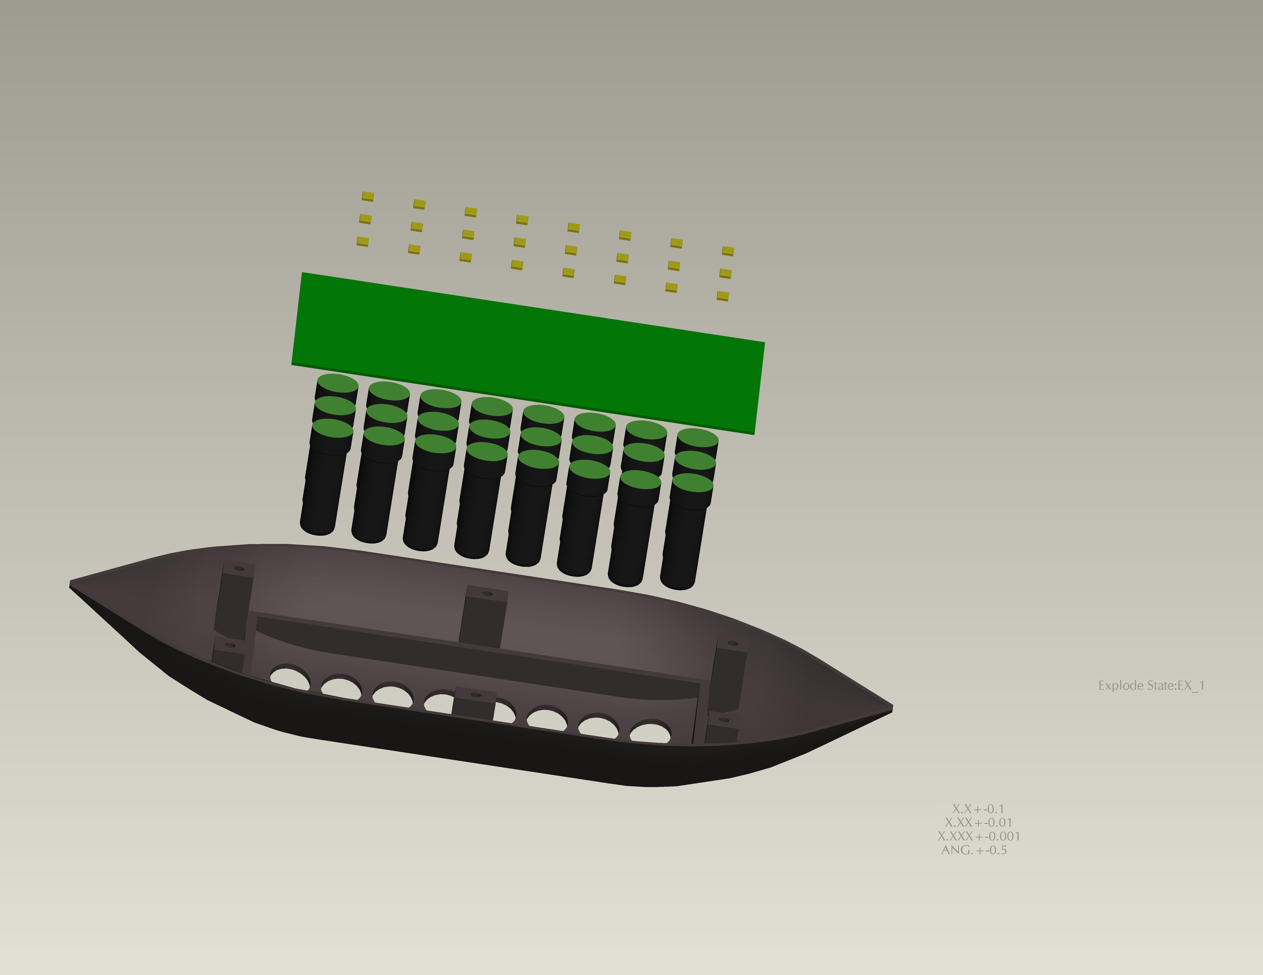
Antenna Cover
Antenna Elements
Ground Plane/ Board
High Power Amplifiers

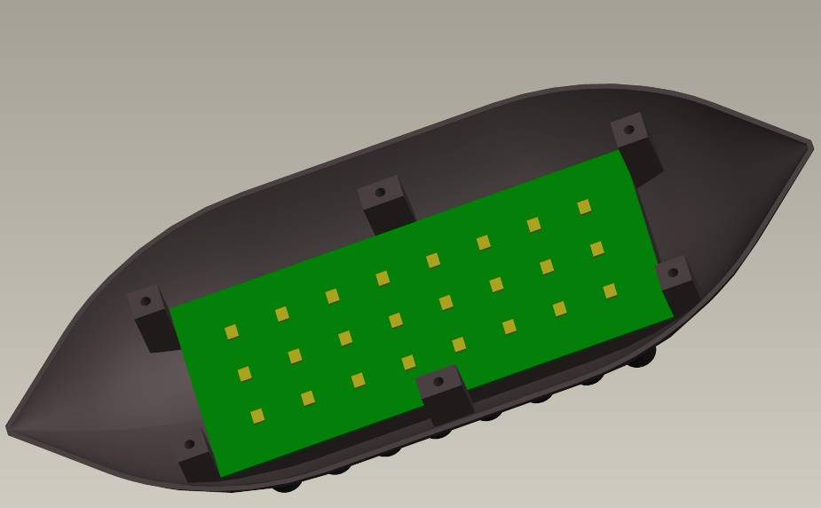

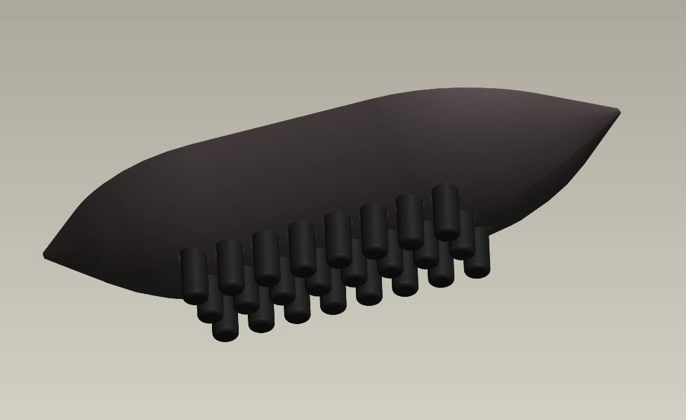

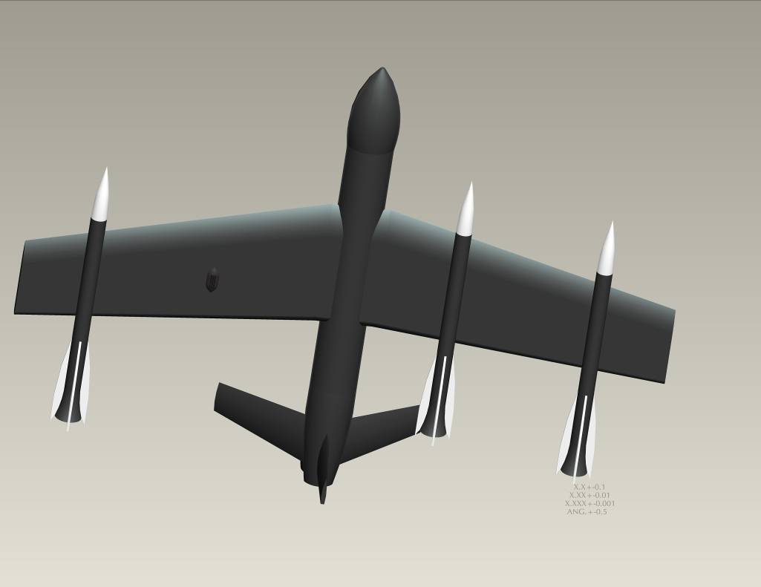
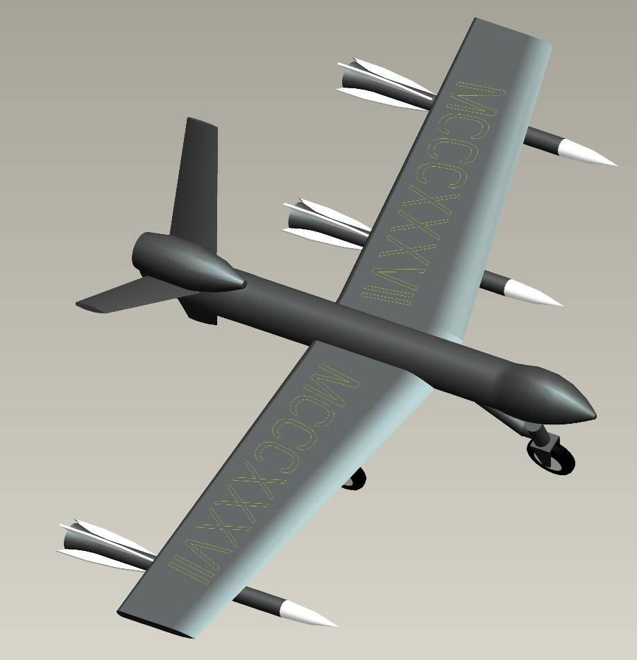

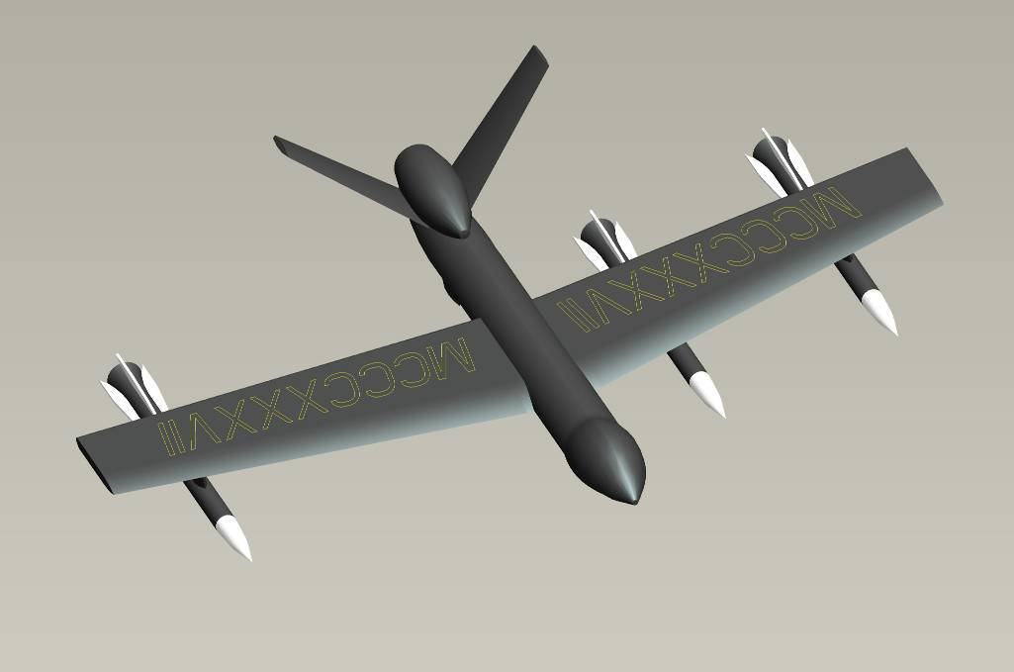

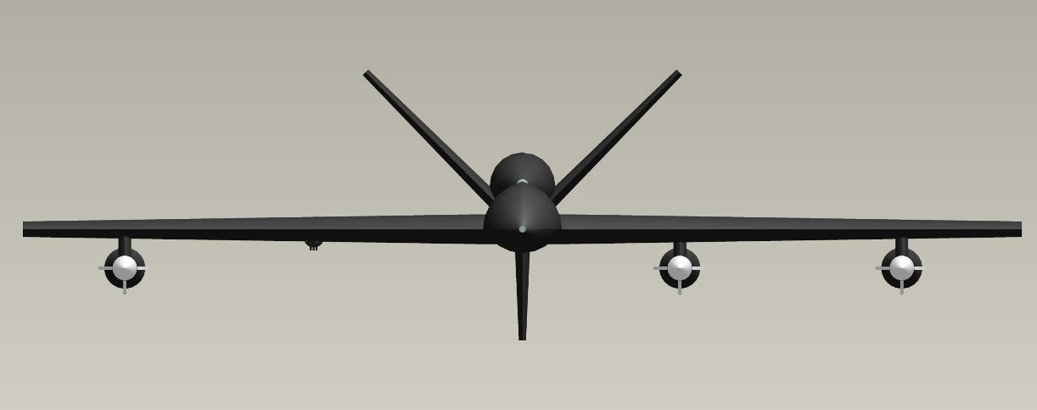
Structural Substantiation of Antenna Assembly

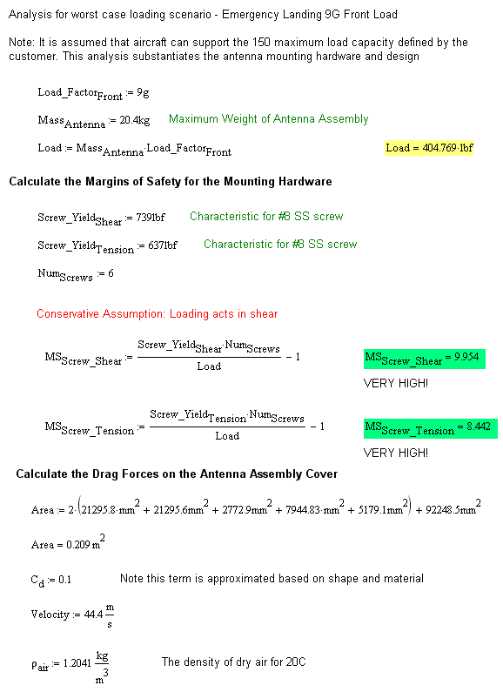

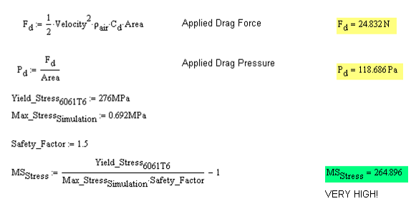

Stress Analysis on Antenna Assembly Cover (ANSYS Workbench Used) – These values were used to calculate the MS_{stress} value for the cover

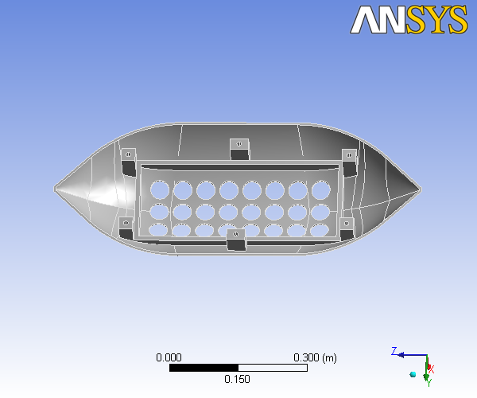

Units
TABLE 1
Unit System | Metric (m, kg, N, °C, s, V, A)
Angle | Degrees
Rotational Velocity | rad/s

Model

Geometry
TABLE 2
Model > Geometry
Object Name | Geometry
State | Fully Defined
Definition
Source | C:\Week5 TDC - UAV\ANTENNA_COVER.PRT.6
Type | ProEngineer
Length Unit | Millimeters
Element Control | Program Controlled
Display Style | Part Color
Bounding Box
Length X | 0.12605 m
Length Y | 0.3434 m
Length Z | 0.80176 m
Properties
Volume | 1.7945e-003 m³
Mass | 4.9709 kg
Statistics
Bodies | 1
Active Bodies | 1
Nodes | 12119
Elements | 5620
Preferences
Import Solid Bodies | Yes
Import Surface Bodies | No
Import Line Bodies | No
Parameter Processing | Yes
Personal Parameter Key | DS
CAD Attribute Transfer | No
Named Selection Processing | No
Material Properties Transfer | Yes
CAD Associativity | Yes
Import Coordinate Systems | No
Reader Save Part File | No
Import Using Instances | Yes
Do Smart Update | No
Attach File Via Temp File | No
Analysis Type | 3-D
Mixed Import Resolution | None
Enclosure and Symmetry Processing | Yes
TABLE 3
Model > Geometry > Parts
Object Name | ANTENNA_COVER
State | Meshed
Graphics Properties
Visible | Yes
Transparency | 1
Definition
Suppressed | No
Material | Aluminum Alloy
Stiffness Behavior | Flexible
Nonlinear Material Effects | Yes
Bounding Box
Length X | 0.12605 m
Length Y | 0.3434 m
Length Z | 0.80176 m
Properties
Volume | 1.7945e-003 m³
Mass | 4.9709 kg
Centroid X | 1.769e-003 m
Centroid Y | -2.5176e-005 m
Centroid Z | 2.2648e-005 m
Moment of Inertia Ip1 | 0.22784 kg·m²
Moment of Inertia Ip2 | 0.18831 kg·m²
Moment of Inertia Ip3 | 4.6929e-002 kg·m²
Statistics
Nodes | 12119
Elements | 5620

Mesh
TABLE 4
Model > Mesh
Object Name | Mesh
State | Solved
Defaults
Physics Preference | Mechanical
Relevance | 0
Advanced
Relevance Center | Coarse
Element Size | Default
Shape Checking | Standard Mechanical
Solid Element Midside Nodes | Program Controlled
Straight Sided Elements | No
Initial Size Seed | Active Assembly
Smoothing | Low
Transition | Fast
Statistics
Nodes | 12119
Elements | 5620

Static Structural
TABLE 5
Model > Analysis
Object Name | Static Structural
State | Fully Defined
Definition
Physics Type | Structural
Analysis Type | Static Structural
Options
Reference Temp | 22. °C
TABLE 6
Model > Static Structural > Analysis Settings
Object Name | Analysis Settings
State | Fully Defined
Step Controls
Number Of Steps | 1.
Current Step Number | 1.
Step End Time | 1. s
Auto Time Stepping | Program Controlled
Solver Controls
Solver Type | Program Controlled
Weak Springs | Program Controlled
Inertia Relief | Off
Nonlinear Controls
Force Convergence | Program Controlled
Moment Convergence | Program Controlled
Displacement Convergence | Program Controlled
Rotation Convergence | Program Controlled
Line Search | Program Controlled
Output Controls
Calculate Stress | Yes
Calculate Strain | Yes
Calculate Results At | All Time Points
Analysis Data Management
Solver Files Directory | C:\Week5 TDC - UAV\ANTENNA_COVER Simulation Files\Static Structural\
Future Analysis | None
Save ANSYS db | No
Delete Unneeded Files | Yes
Nonlinear Solution | No
TABLE 7
Model > Static Structural > Loads
Object Name | Fixed Support | Pressure | Force
State | Fully Defined
Scope
Scoping Method | Geometry Selection
Geometry | 1 Face | 11 Faces | 1 Face
Definition
Type | Fixed Support | Pressure | Force
Suppressed | No
Define By |  | Components
X Component |  | 0. Pa (ramped) | 200. N (ramped)
Y Component |  | 0. Pa (ramped) | 0. N (ramped)
Z Component |  | 118. Pa (ramped) | 0. N (ramped)
FIGURE 1
Model > Static Structural > Pressure
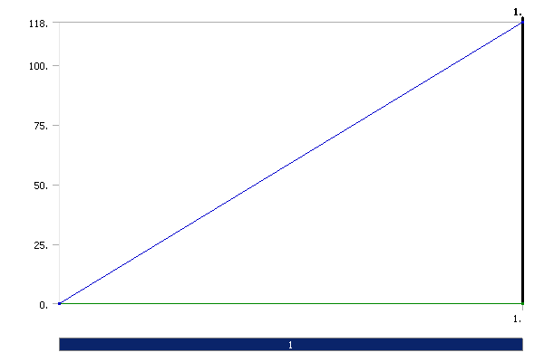
FIGURE 2
Model > Static Structural > Force
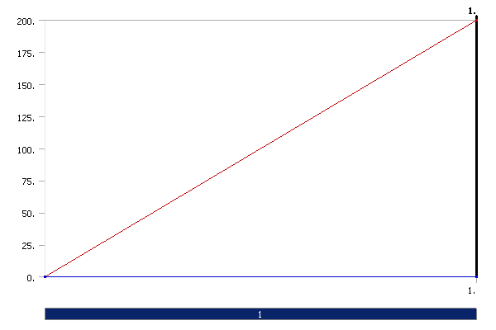

Solution
TABLE 8
Model > Static Structural > Solution
Object Name | Solution
State | Solved
Adaptive Mesh Refinement
Max Refinement Loops | 1.
Refinement Depth | 2.
TABLE 9
Model > Static Structural > Solution > Solution Information
Object Name | Solution Information
State | Solved
Solution Information
Solution Output | Solver Output
Newton-Raphson Residuals | 0
Update Interval | 2.5 s
Display Points | All
TABLE 10
Model > Static Structural > Solution > Results
Object Name | Equivalent Stress | Total Deformation
State | Solved
Scope
Geometry | All Bodies
Definition
Type | Equivalent (von-Mises) Stress | Total Deformation
Display Time | End Time
Results
Minimum | 232.23 Pa | 0. m
Maximum | 6.923e+005 Pa | 1.5871e-003 m
Information
Time | 1. s
Load Step | 1
Substep | 1
Iteration Number | 1

Material Data

Aluminum Alloy
TABLE 11
Aluminum Alloy > Constants
Structural
Young's Modulus | 2.76e+008 Pa
Poisson's Ratio | 0.33
Density | 2770. kg/m³
Thermal Expansion | 2.3e-005 1/°C
Tensile Yield Strength | 2.8e+008 Pa
Compressive Yield Strength | 2.8e+008 Pa
Tensile Ultimate Strength | 3.1e+008 Pa
Compressive Ultimate Strength | 0. Pa
Thermal
Specific Heat | 875. J/kg·°C
Electromagnetics
Relative Permeability | 1.
Resistivity | 5.7e-008 Ohm·m

FIGURE 3
Aluminum Alloy > Thermal Conductivity
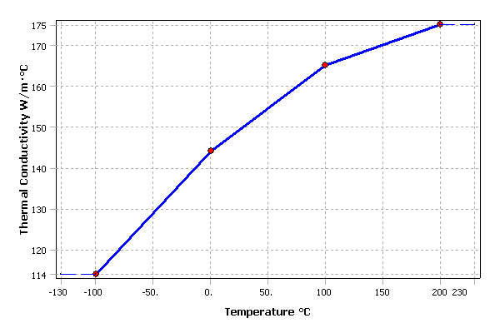
TABLE 12
Aluminum Alloy > Thermal Conductivity > Thermal Conductivity vs. Temperature
Temperature °C | Thermal Conductivity W/m·°C
-100. | 114.
0. | 144.
100. | 165.
200. | 175.

FIGURE 4
Aluminum Alloy > Alternating Stress
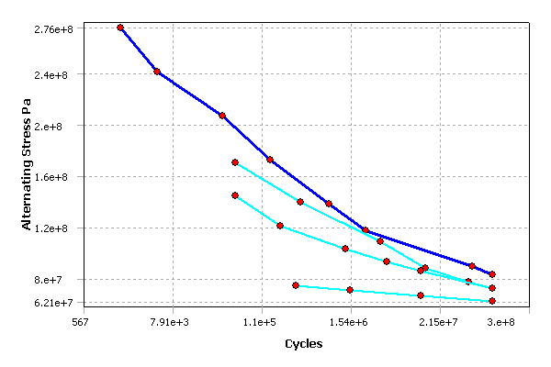
TABLE 13
Aluminum Alloy > Alternating Stress > Property Attributes
Interpolation | Semi-Log
Mean Curve Type | R-Ratio
TABLE 14
Aluminum Alloy > Alternating Stress > Alternating Stress Curve Data
Mean Value
-1.
-0.5
0.
0.5
TABLE 15
Aluminum Alloy > Alternating Stress > Alternating Stress vs. Cycles
Cycles | Alternating Stress Pa
1700. | 2.758e+008
5000. | 2.413e+008
34000 | 2.068e+008
1.4e+005 | 1.724e+008
8.e+005 | 1.379e+008
2.4e+006 | 1.172e+008
5.5e+007 | 8.963e+007
1.e+008 | 8.274e+007
Loading For ANSYS Analysis
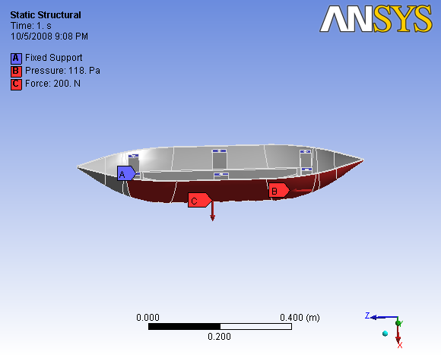

Displacement for ANSYS Analysis
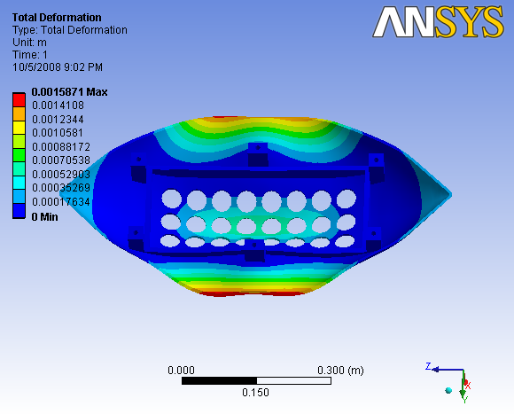

Stress for ANSYS Analysis
